SIMATS ENGINEERING
ASSESSMENT TOOL 2

COURSE NAME: Database Management Systems
COURSE CODE: CSA05

COURSE OUTCOME COVERED
CO1: Analyze DBMS architecture, different data models, schema types, and design ER/EER diagrams, relational schemas for case-based scenarios by identifying entities and relationships. (BL1, BL2)
Activity Tool : Concept Mapping (Medium)
Assessment Tool Weightage: 35%

QUESTIONS

5. Construct a concept map comparing Hierarchical, Network, and
Relational data models with their key properties.

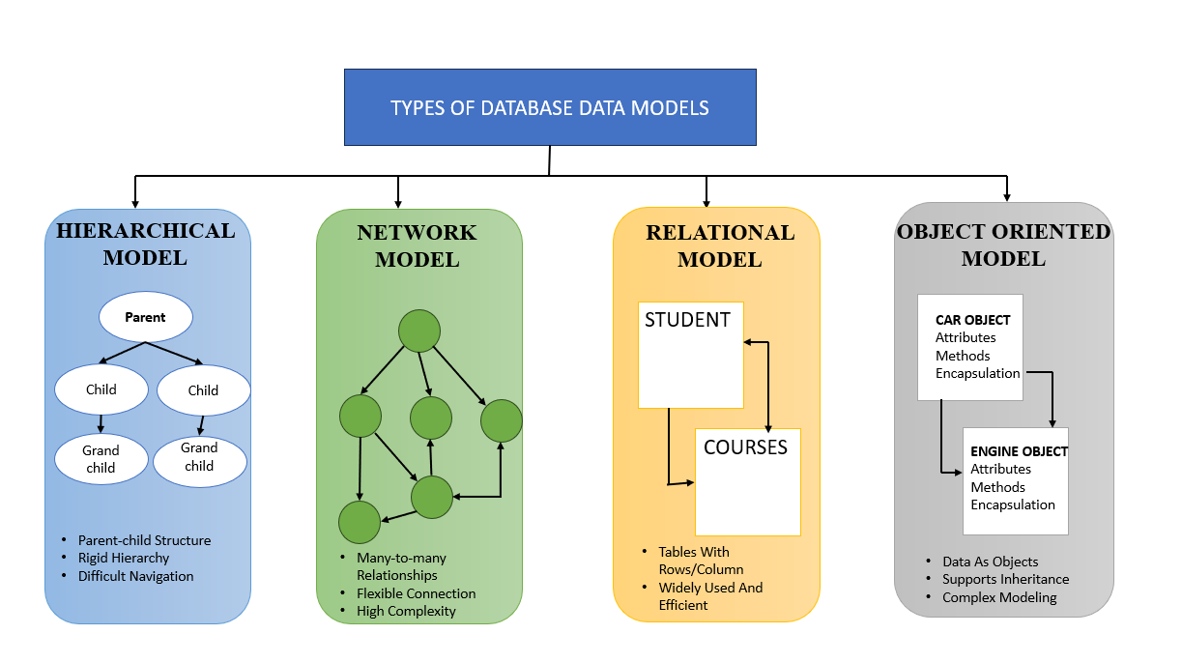

10. Design a concept map for the roles and responsibilities in a DBMS
environment: DBA, End User, Application Developer.

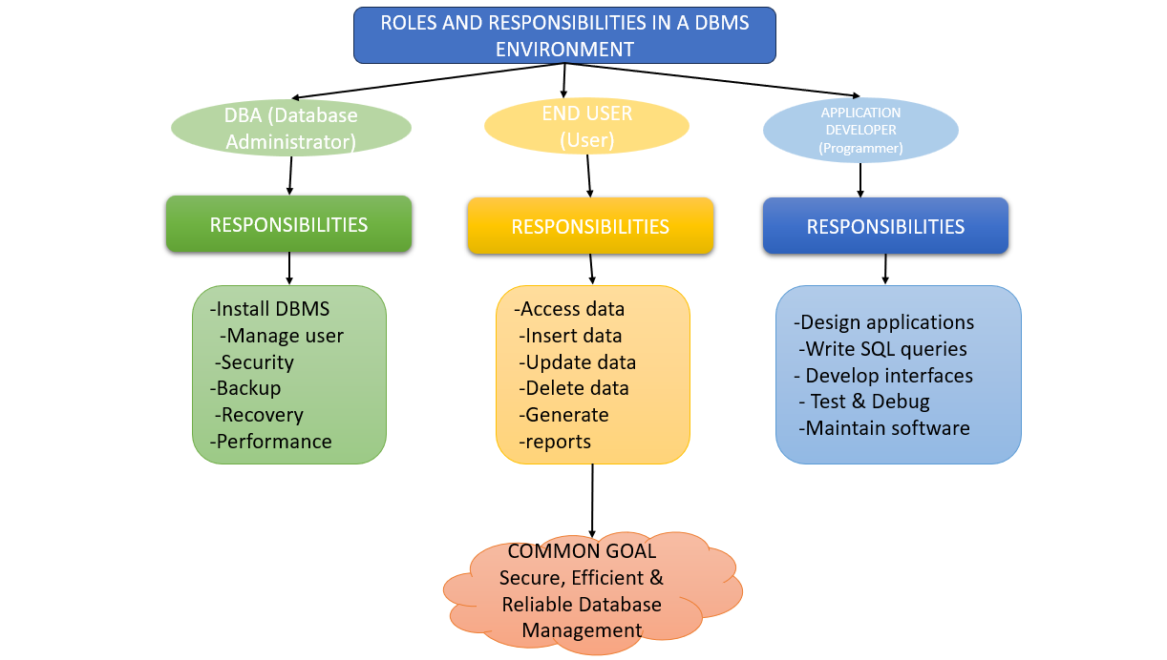

Code of Conduct:
I __M.V.PREETHASHRI(192524476)__ (Name / Reg No) certify that this submission is my
original work and that I have adhered to the guidelines specified for this assessment.
I understand that any violation of academic integrity rules will result in disciplinary
action.
Signature of the student: M.V.PREETHASHRI

